L1 : More about factorization (A)

Overview:

Which one(s) are the factors of 8?

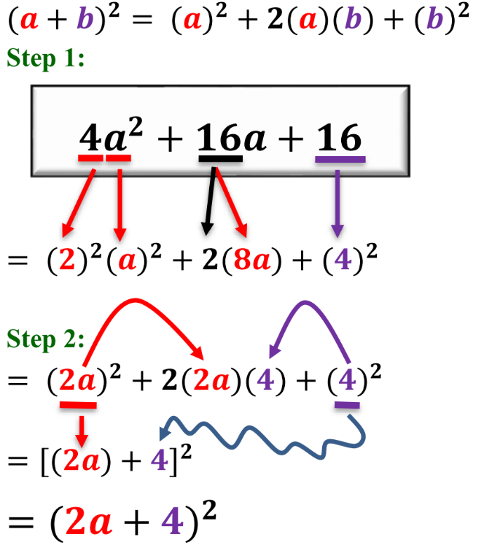
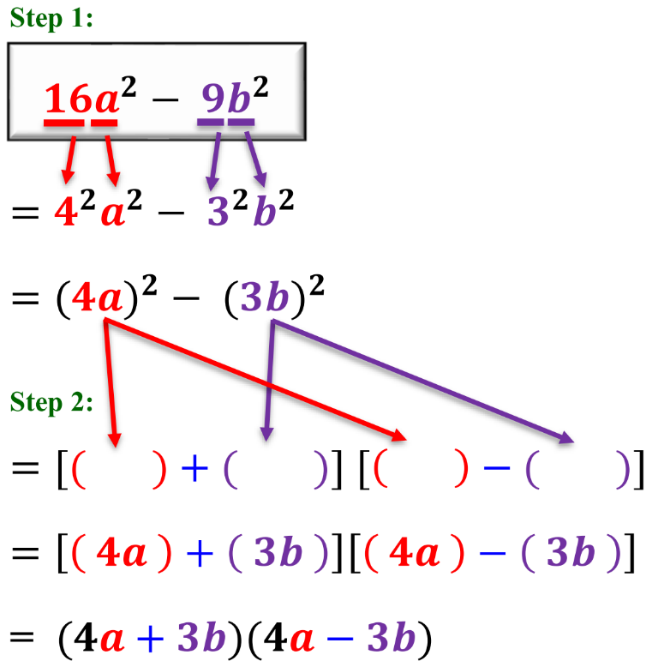
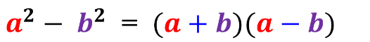
Factorize = Find the factors
∴答案格式一定係 ( )( )
8 = 1 x 8 = (1)(8)
8 = 2 x 4 = (2)(4)
Checkpoint 1

Checkpoint 2
$$a^{2}+2ab+b^{2}={(a+b)}^{2}$$

1
3
5
2
4
6
7
8
Let’s get started!

Factorize the following expressions.

1. $a^{\text{2}}+\text{4}a+\text{4}$

3. $\text{25}d^{\text{2}}+\text{20}d+\text{4}$

5. $\text{16}m^{\text{2}}+\text{8}mn+n^{\text{2}}$

7. 16a² − 1

9. $\text{4}a^{\text{4}}-b^{\text{2}}c^{\text{2}}$

11. (a) Factorize 16x² − 8x + 1.
(b) Hence, factorize 16y⁴ − 8y² + 1.

2. $\text{4}c^{\text{2}}-\text{12}c+\text{9}$

4. $\text{9}b^{\text{2}}-\text{6}b+\text{1}$

6. $p^{\text{2}}-\text{10}pq+\text{25}q^{\text{2}}$

8. $\text{36}m^{\text{2}}-\text{25}n^{\text{2}}$

10. 32x² − 50y²

12. (a) Factorize 5x² + 20x + 20.
(b) Hence, factorize 5x² + 20x − 25.

You have learnt more!
Go on!
$$x^{2}$$
$$x$$
$$x$$

$$2$$
$$+2$$
$$+1$$

$$x$$
$$x$$

$$+2$$
$$+1$$

$$(x+2)$$
$$(x+1)$$
$$x^{2}+3x+2= (x+2)(x+1)$$

$$x$$
$$x$$

$$+2$$
$$+1$$

Multiply
1
2
$$\left(x\right)\left(+1\right)$$
$$x$$
$$\left(x\right)\left(+2\right)$$
$$2x$$
$$+$$
$$=3x$$
$$x^{2}+3x+2$$

Factorize the following expressions.
Checkpoint 3
Factorize x² + 3x + 2

13. $x^{\text{2}}+\text{4}x+\text{3}$

15. $a^{\text{2}}+\text{6}a+\text{5}$

17. $c^{\text{2}}+\text{5}c+\text{6}$

19. $p^{\text{2}}+\text{8}pq+\text{15}q^{\text{2}}$

21. $a^{\text{2}}+\text{13}ab+\text{30}b^{\text{2}}$

14. $y^{\text{2}}+\text{8}y+\text{7}$

16. $b^{\text{2}}+\text{12}b+\text{11}$

18. $d^{\text{2}}+\text{7}d+\text{10}$

20. $m^{\text{2}}+\text{12}mn+\text{35}n^{\text{2}}$

22. $x^{\text{2}}+\text{17}xy+\text{30}y^{\text{2}}$

$$x^{2}$$
$$x$$
$$x$$

$$2$$
$$+2$$ | $$-2$$
$$+1$$ | $$-1$$

$$x$$
$$x$$

$$-2$$
$$-1$$

$$(x-2)$$
$$(x-1)$$
$$x^{2}-3x+2= (x-2)(x-1)$$

$$x$$
$$x$$

$$-2$$
$$-1$$

Multiply
1
2
$$\left(x\right)\left(-1\right)$$
($-x$)
$$\left(x\right)\left(-2\right)$$
($-2x$)
$$+$$
$$=-3x$$
$$x^{2}-3x+2$$

Keep Fighting!

Factorize the following expressions.
Checkpoint 4
Factorize x² - 3x + 2

23. $x^{\text{2}}-\text{14}x+\text{13}$

25. $w^{\text{2}}-\text{8}w+\text{12}$

27. $p^{\text{2}}-\text{11}p+\text{2}\text{8}$

29. $r^{\text{2}}-\text{9}rs+\text{20}s^{\text{2}}$

31. $s^{\text{2}}-\text{19}st+\text{70}t^{\text{2}}$

24. $y^{\text{2}}-\text{13}y+\text{12}$

26. $z^{\text{2}}-\text{7}z+\text{12}$

28. $q^{\text{2}}-\text{16}q+\text{28}$

30. $a^{\text{2}}-\text{18}ab+\text{56}b^{\text{2}}$

32. $α^{\text{2}}-\text{16}αβ+\text{48}β^{\text{2}}$

Factorize the following expressions.
33. $a^{\text{2}}+\text{5}a+\text{6}$

35. $b^{\text{2}}-\text{12}b+\text{27}$

37. $x^{\text{2}}-\text{15}x+\text{36}$

39. $m^{\text{2}}-\text{10}mk+\text{21}k^{\text{2}}$

41. $s^{\text{2}}+\text{1}\text{5}st+\text{26}t^{\text{2}}$

43. $\text{5}c^{\text{2}}-\text{40}cd+\text{75}d^{\text{2}}$

45. $u^{\text{2}}t^{\text{2}}+\text{13}uvt+\text{22}v^{\text{2}}$

34. $a^{\text{2}}+\text{5}+\text{6}a$

36. $\text{3}b^{\text{2}}-\text{36}b+\text{81}$

38. $\text{2}x^{\text{2}}+\text{30}x+\text{72}$

40. $m^{\text{2}}n-\text{10}mnk+\text{21}k^{\text{2}}n$

42. $26s^{\text{2}}-\text{1}\text{5}st+t^{\text{2}}$

44. $p^{\text{3}}+\text{1}\text{8}p^{\text{2}}t+\text{45}pt^{\text{2}}$

46. $x^{\text{4}}-\text{16}x^{\text{2}}y^{\text{2}}+\text{63}y^{\text{4}}$

Give it a try


Final Ans:
$$x^{2}+2x-3=(x+3)(x-1)$$
$$x^{2}$$
$$x$$
$$x$$

$$-3$$
$$+3$$ | $$-3$$
$$-1$$ | $$+1$$

$$x$$
$$x$$

$$-3$$
$$+1$$

Multiply
1
2
$$\left(x\right)\left(+1\right)$$
($x$)
$$\left(x\right)\left(-3\right)$$
($-3x$)
$$+$$
$$=-2x$$
$$x^{2}+2x+3$$

Trial 2
$$x^{2}$$
$$x$$
$$x$$

$$-3$$
$$+3$$ | $$-3$$
$$-1$$ | $$+1$$

$$x$$
$$x$$

$$+3$$
$$-1$$

Multiply
1
2
$$\left(x\right)\left(-1\right)$$
($-x$)
$$\left(x\right)\left(+3\right)$$
($3x$)
$$+$$
$$=2x$$
$$x^{2}+2x+3$$

Trial 1
Checkpoint 5
Factorize $x^{2}+2x-3$
最尾係正, 正正負負
最尾係負, 正負正負
$(a+1)(a+2)$ $(a-1)(a-2)$ $(a+1)(a-2)$

Expand the following expressions.

Factorize the following expressions.
47. $x^{\text{2}}+\text{2}x-\text{3}$

49. $y^{\text{2}}+\text{3}y-\text{10}$

51. $h^{\text{2}}-\text{14}h-\text{51}$

53. $r^{\text{2}}-\text{8}r-\text{33}$

55. $x^{\text{2}}-\text{11}xy-\text{42}y^{\text{2}}$

57. $c^{\text{2}}+\text{19}cd-\text{120}d^{\text{2}}$

48. $x^{\text{2}}-\text{2}x-\text{3}$

50. $y^{\text{2}}-\text{3}y-\text{10}$

52. $n^{\text{2}}+\text{16}n-\text{57}$

54. $k^{\text{2}}+\text{3}k-\text{54}$

56. $a^{\text{2}}-\text{9}ab-\text{52}b^{\text{2}}$

58. $p^{\text{2}}+\text{14}pq-\text{72}q^{\text{2}}$

Final Boss!

Factorize the following expressions.
59. $c^{\text{2}}-\text{28}d^{\text{2}}+\text{3}cd$

61. $-\text{6}st+s^{\text{2}}-\text{91}t^{\text{2}}$

63. $-u^{\text{2}}-\text{13}uv+\text{68}v^{\text{2}}$

65. $x^{\text{2}}-\text{36}y^{\text{2}}-\text{9}xy$

67. $\text{2}p^{\text{2}}-\text{19}pq+\text{45}q^{\text{2}}$

69. $-\text{119}θϕ-\text{42}θ^{\text{2}}+\text{98}ϕ^{\text{2}}$

60. $p^{\text{2}}+\text{40}q^{\text{2}}-\text{14}pq$

62. $-r^{\text{2}}+\text{17}rs-\text{70}s^{\text{2}}$

64. $-\text{68}n^{\text{2}}-\text{21}mn-m^{\text{2}}$

66. $\text{3}a^{\text{2}}-\text{15}ab-\text{42}b^{\text{2}}$

68. $\text{3}h^{\text{2}}-\text{16}hk-\text{35}k^{\text{2}}$

70. $\text{24}α^{\text{4}}γ^{\text{2}}+\text{90}β^{\text{4}}γ^{\text{2}}-\text{94}α^{\text{2}}β^{\text{2}}γ^{\text{2}}$

